Why Docker

It’s a revolution

90’s Mainframe -> PC

00’s Baremetal -> Virtual

10’s Datacenter -> Cloud

Now Host -> Container /Serverless

By 2020, 50% of global organizations will run containers in production environments.

Benefits of Adopting Docker

1. Speed-- make the business more agile.

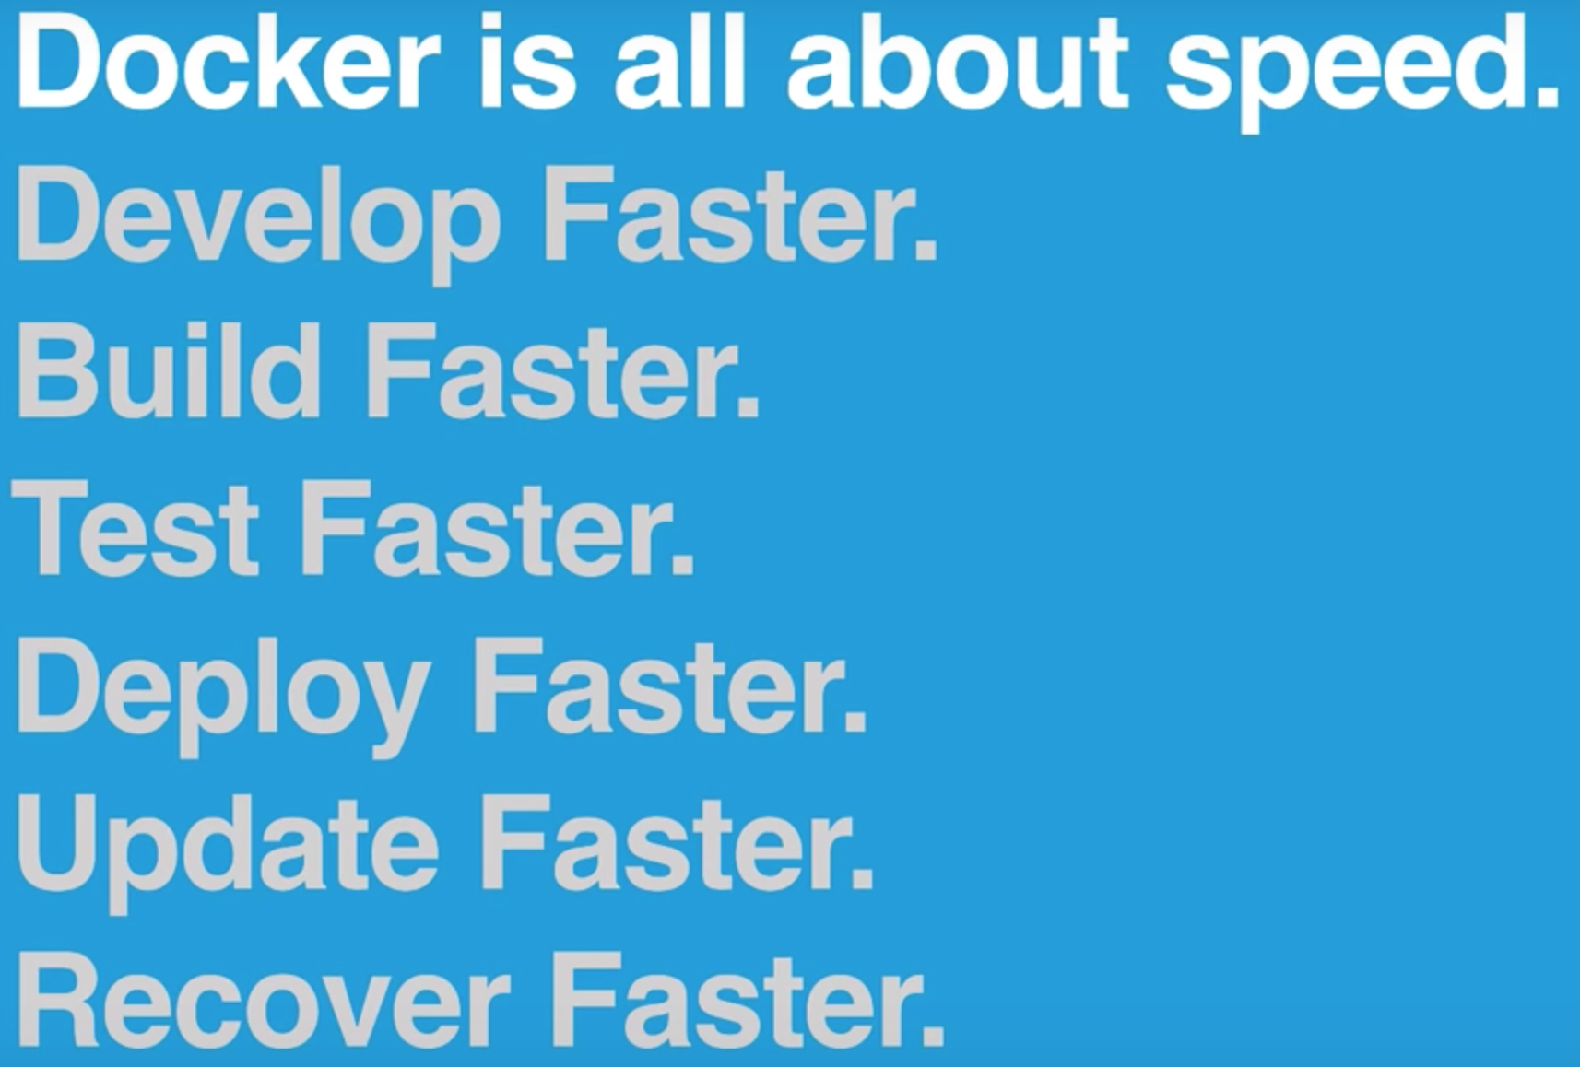

1. Reduce complexity.

Docker contains what it depends on.

Reduce maintenances expense.

1. Opensource, large communities

Real word examples.



Time spent: 30 min